LOAN ORIGINATOR

File Submission Checklist

Important Notes:
- Always open a new copy of any linked documents instead of downloading them to ensure the most recent version.
- The most recent updates within this document will be highlighted in yellow.
- Major process updates can be found in the appendices.
- Documents with checklists/dropdowns MUST be opened in the desktop app for full functionality.

Contents

Overview 1
Submission Checklist 2
ARIVE Notes Table 6
Loan Narrative 7
Appendix A: VA-Specific Actions 9
Appendix B: FHA-Specific Actions 11
Appendix C: USDA-Specific Actions 12
Appendix D: Service Level Agreements (SLAs) 13
Appendix E: Document Labeling Format for ARIVE 13

Overview
This document provides Loan Originators a step-by-step guide for submitting loans to the Operations team. This document also includes appendices for additional considerations when submitting government loans, Operations SLAs and document labeling standards.

Submission Checklist
Mark each item as “Done” to ensure you don’t miss anything when submitting your file.
Open this document in the Desktop Version of MS Word to use the dropdown menus below
Action |  |  | Complete? | Resources
LOAN & PROPERTY TAB
Confirm accuracy of all fields |  |  | Incomplete | Video
Hard-Pull Credit Report on NBS & upload to ARIVE  Only for community property state + gov. loan |  |  | N/A | Community Prop. Info
Condo/ PUD Only | Add to Loan Narrative if “Full”, “Limited”, or “No” Condo Review needed  *For conventional loans, please refer to each lender’s approved list in their TPO* |  | N/A | Loan Narrative  FHA Approved List  VA Approved List
BORROWER INFO TAB
Confirm accuracy of all fields |  |  | Incomplete | Video
FINANCIAL INFO TAB
Confirm accuracy of all fields  Use “Master Income Calculator” or “Analyze Income” tool for complex files |  |  | Incomplete | Video
Add Gift Funds under assets  Remember to:  - Write about the gift situation in the Loan Narrative  - Provide gift donor’s info in ARIVE submission note OR create a client need for this information |  |  | N/A | Setting Expectations w/ Borrower
PRODUCTS & PRICING TAB
Choose: lender, product, rate, pricing & rate lock period |  |  | Incomplete | Video  Request Pricing Exception
Confirm “Fee In Price” option is selected |  |  | Incomplete | Video  Request Pricing Exception
Locking Only | Confirm pricing is active  Daily pricing is active at 11AM ET, day of submission |  | N/A | Video  Request Pricing Exception
If non-QM “manual” lender  Email lender AE & CC submissions@localprocessing.com  Only if pricing with “manual” lenders not integrated with ARIVE |  |  | N/A | Video  AE Contact Info  List of ARIVE Integrated Lenders & Manual Lenders
FOR LOCK REQUESTS ONLY  Insert screenshot of “Product Info” box into ARIVE Notes  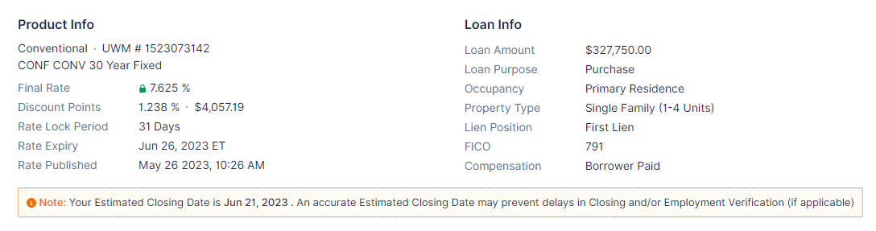  Uncheck the “Notify Users” box under your ARIVE Note |  |  | Incomplete | -
FOR LOCK REQUESTS ONLY  Insert screenshot of pricing “Rate Stack” into ARIVE notes  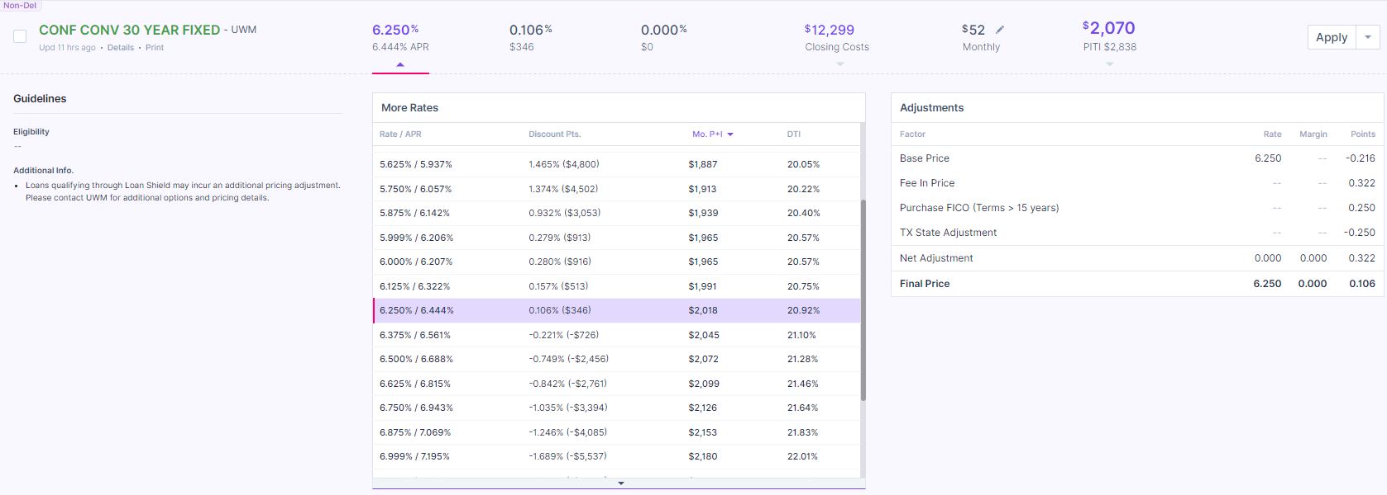  Uncheck the “Notify Users” box under your ARIVE Note |  |  | Incomplete | -
FEES TAB
Confirm accuracy of all fields  Option 1: Upload Preliminary CD to ARIVE  Option 2: Import “Smart Fees” (If using Smart Fees, they must be imported within 24 hours of submission)  You must use Smart Fees if you do not have a prelim CD from a title company |  |  | Incomplete | video
Confirm accuracy of corporate-mandated fees:  - Box A: Processing Fee= >$1395  - Box B: Credit Report Fee= >$265/per Report  Loan Coordinator may add additional product or state fees |  |  | Incomplete | -
Download “IFW” and upload to ARIVE |  |  | Incomplete | Video
DUAL AUS TAB
Confirm receipt of “Approved/Eligible” findings  AUS must be run within 24 hours of submission with property address |  |  | Incomplete | video
SETUP & CONTACTS TAB
Confirm accuracy of “Key Dates” fields |  |  | Incomplete | Video
Add “Business Contacts”  Title Agent- name, email, address, phone |  |  | Incomplete | Video
Purchase Only |  | Add “Business Contacts”  Buyer’s Agent & Seller’s Agent- name, email, phone, company name, address | N/A | Video
Condo/ PUD Only |  | Add “Business Contacts”  HOA Agent- name, email, phone, company name, address  *Please proceed and provide the contact info ASAP if you cannot obtain this info during submission* | N/A | Video
Confirm accuracy of “Milestone Emails” settings |  |  | Incomplete | Video
CLIENT NEEDS TAB
Create and send “Client Needs” list |  |  | Incomplete | Video
DOCUMENTS TAB
Upload required documents |  |  | Incomplete | Basic Submission Docs
Confirm documents are labeled & classified correctly |  |  | Incomplete | Video  Document Labels
SETUP & CONTACTS TAB
Complete Loan Narrative & copy/paste into the “Loan Narrative” box |  |  | Incomplete | Video
Add ‘Submissions’ to “Loan Team”  Do not add your LC or Processor by name |  |  | Incomplete | Video
ARIVE NOTES TABLE
Complete ARIVE Notes Table & copy/paste into ARIVE Notes  Uncheck the “Notify Users” box under your ARIVE Note |  |  | Incomplete | Video
LOAN CENTER TAB
Tag @Submissions in ARIVE Notes  Do not tag your LC or Processor by name |  |  | Incomplete | -
Click “Send To Processing” to move file to Loan Setup status |  |  | Incomplete | Video

ARIVE Notes Table
Fill out all sections in the table below and copy/paste the table into the ARIVE Notes prior to submitting your file.
Open this document in the Desktop Version of MS Word to use the dropdown menus below
LOAN STRUCTURE
Date and Time of interest rate updated/selected in ARIVE |  |  |  |  |  | 5/15/24 XX:XX AM/PM
Lock or Float? | Make a selection |  | Non-QM Manual Pricing? |  |  | Make a selection
(Purchases) Is this a FSBO transaction? |  | Make a selection |  | Is there a temporary rate buydown? |  | Make a selection | Type: N/A
Escrows/ Impounds? | Make a selection |  |  |  | UWM CYP? | Make a selection | # of bps:
THIRD PARTY SERVICES
When should the appraisal be ordered? If after inspection date, add date to Loan Narrative |  |  |  |  |  | Make a selection
Does Operations need to request a rush for the appraisal? |  |  |  |  |  | Make a selection
Which AMC do you prefer to work with? |  |  |  |  |  | Make a selection | Other:
NON-BORROWING SPOUSE INFORMATION
NBS: full name, email, & phone If no NBS, put N/A |  |  |  |  |  | N/A
If NBS, are they listed on title/vesting? |  |  |  |  |  | N/A
Have you confirmed the manner in which title will be held? |  |  |  |  |  | Make a selection
FINAL CHECKS
Confirmation: Screenshots of the “Product Info” box and “Rate Stack” are in ARIVE Notes Only for loans with lock requests |  |  |  |  |  | Make a selection
Confirmation: Preliminary CD is uploaded to ARIVE OR “Smart Fees” have been imported in the last 24 hours |  |  |  |  |  | Make a selection
Confirmation: My fees in the ARIVE “Fee Tab” are accurate |  |  |  |  |  | Make a selection
Confirmation: I ran AUS in the last 24 hours will s and received “Approved/Eligible” findings with the property address |  |  |  |  |  | Make a selection
Confirmation: I completed all the fields in the Loan Narrative and copy/pasted it into the “Loan Narrative” box in ARIVE |  |  |  |  |  | Make a selection
Confirmation: Does the LC need prior approval from you before disclosing the file? If no, the LC will auto-disclose & LO accepts risk of potential LE changes |  |  |  |  |  | Make a selection

Loan Narrative
Complete the table below & paste it into the “Loan Narrative” box in the “Setup & Contacts” tab. Do not leave any fields blank.
Income used to qualify: | [Do not leave blank]
Funds to be used for Down Payment & Closing Costs: | [Do not leave blank]
Credit & Liabilities Issues: | [Do not leave blank]
Additional Loans and/or Existing Property: | [Do not leave blank]
Items still Pending or Transferred; Appraisal Orders/Rush: | [Do not leave blank]
Potential Flags: | [Do not leave blank]
Additional Notes: | [Do not leave blank]
Example questions & topics for each section:

- Income used to qualify: How did you calculate? Are you using rental, commission, OT, etc? Any special circumstances such as gaps, seasonal, etc?
- Funds to be used for DP & Closing Costs: Checking, 401k, gift funds & how will they be received, etc?
- Credit & Liabilities Issues: What debt will be omitted and has the account been paid off? Is the borrower willing to pay off any debt if DTI is tight? Does client pay child support/how much?
- Additional Loans and/or Existing Property: Are there existing properties that will be sold prior to the NEW Home Purchase? If so, what is the closing date for the existing property? What is the Title Contact info for the existing property sale? 2nd, bridge, piggyback loans, or has borrower applied for a county DPA, etc?
- Items still Pending or Transferred; Appraisal Orders/Rush: Are there any file contacts (i.e. HOI) that are still pending? Have you ordered a WVOE? Are there documents you’re waiting on? Appraisal Transfers: has the case # been transferred and who is the AMC it’s currently with? On appraisal orders that will not be ordered right away, provide the order date, are we waiting on inspection?
- Potential Flags: Is this a TBD underwrite? Did you get “Refer/Eligible” findings? 1007 appraisal and rent schedule needed?, Survey fees, water test fees, HOA fees, etc.? Are there gaps in employment? Client has judgments, subordinations, etc? Loan is closing in a trust? On Manufactured Homes, do we have a Foundation Certificate and IBTS? Is there a POA? Construction projects with possible health/safety hazards?
- Additional Notes: Borrower’s preferred contact method? Borrower’s Preferred Timeframe to reach out and dates borrower will be out of town or unavailable? Your relationship with the borrower/realtor? What should we know about them? How can we personalize the file?

Appendix A: VA-Specific Actions
This checklist contains common actions to perform or consider on VA loans to ensure you don’t miss anything when submitting your government file at Local Processing LLC.
Open this document in the Desktop Version of MS Word to use the dropdown menus below
Action |  | Complete? | Resources
VA Handbook
LOAN & PROPERTY TAB
Condo/ PUD Only | Confirm condo development is accepted by VA | N/A | VA LGY  Condo Report
New Construc. Only | Confirm builder is active with VA | N/A | VA LGY  Builder Report
VA LOAN TAB
Confirm accuracy of all fields |  | Incomplete | -
SETUP & CONTACTS TAB
Active Duty Only | Add CO (Commanding Officer) to “Business Contacts” so SOS (Statement of Service) can be obtained | N/A | -
DOCUMENTS TAB
Upload COE  Review eligibility, exemption status, entitlement & usage |  | Incomplete | VA Handbook  Ch 2
Confirm PA includes “VA/FHA Amendatory Clause” and “Real Estate Cert Addendums” |  | Incomplete | -
House On a Well Only | Order Nitrates, Nitrites, and Bacteria test  (Direct questions to buyer’s agent) | N/A | -
Property is on a Private Street with No HOA Only | Order a Private Road Maintenance or Road Maintenance Agreement (PRMA or RMA) | N/A | -
Active Duty Only | PCS Orders have been obtained if borrower is purchasing prior to transfer | N/A | -
Active Duty Only | If ETS (Expiration of Term of Service) date is 1 year or less, provide:  Option 1: Commitment to re-enlist letter  Option 2: New job offer letter with all terms | N/A | -
FINAL CHECKS
Purchase Only | Confirm spoke to realtor about comps that support the offer & pest inspection | N/A | -
Purchase Only | Confirm you talked to realtor about recent comps to support the offer and the pest inspection | N/A | -
Active Duty Only | BAH (Basic Allowance for Housing) rate re-calculated based on the new duty station location if purchasing prior to relocation and new paystubs are available | N/A | -
Deployed Borrower Only | Confirm if Power of Attorney needed and discuss with Closing Agent, Borrowers, and Lender | N/A | -

Appendix B: FHA-Specific Actions
This checklist contains common actions to perform or consider on FHA loans to ensure you don’t miss anything when submitting your government file at Local Processing.
Open this document in the Desktop Version of MS Word to use the dropdown menus below
Complete | Action | Resources
FHA
FHA Guidelines
Select from Dropdown | FHA Amendatory Clause and Real Estate Cert Addendums are included in the purchase agreement
Select from Dropdown | Has the property had a recent sale/transfer within 91-180 days? If resale price is 100% over purchase price paid by seller to acquire property, a 2nd full appraisal from a different appraiser is required
Select from Dropdown | Condo Development has been accepted by FHA | HUD Approved Condo
Select from Dropdown | Health and safety property issues to consider: Is there peeling paint, broken windows, deferred maintenance, missing handrails etc?
Select from Dropdown | Manufactured homes: Confirm home was built on or after June 15, 1976 with a HUD tag
Select from Dropdown | Manufactured homes: Has title been surrendered for the manufactured home on the property?
Select from Dropdown | Manufactured homes: Confirm manufactured home has been permanently fixed to the foundation
Select from Dropdown | Is this property on a private street with no HOA? A recorded Private Road Maintenance or Road Maintenance Agreement (PRMA or RMA) must be obtained
Select from Dropdown | Is this home on a well? (Direct question to buyer’s agent. Nitrates, nitrites, and bacteria would need to be ordered) Order test if necessary
Select from Dropdown | Is the borrower(s) using income from multiple jobs? Must have 2-year history of working at both

Appendix C: USDA-Specific Actions
This checklist contains common actions to perform or consider on USDA loans to ensure you don’t miss anything when submitting your government file at Local Processing.
Open this document in the Desktop Version of MS Word to use the dropdown menus below
Complete | Action | Resources
USDA
USDA Handbook
Select from Dropdown | Is the property eligible for a USDA loan? | Eligibility Map
Select from Dropdown | Have you documented income for all household members? (in some instances income must be calculated from assets, see guidelines)
Select from Dropdown | Have you received the actual 2 years tax returns? (tax transcripts cannot be used)
Select from Dropdown | Did you export the MISMO 3.4 from ARIVE into GUS? Note: Do not run DU or LPA
Select from Dropdown | Did you run income and property eligibility through usda.gov?
Select from Dropdown | After submitting GUS findings with your file, did you send the 3555-21 Form to borrower for eSignature? (in GUS under Request Forms page)
Select from Dropdown | Manufactured homes: Manufactured date must be 12 or less months of the purchase agreement. Manufactured home must also be purchased directly from the builder/manufacturer

